TSFS03: Assignment 2, Tutorial 3

Welcome back. This is the last tutorial for hand-in 2. We’re almost there.
This tutorial is an introduction to the optimization methods we will use to solve the energy management problem.
Before this tutorial, you should have completed the first part of hand-in 2. That is, you should have two functions, parallelHybrid() and seriesHybrid(), that output correct fuel consumptions for the test cases provided with the project tasks. If you only finished the parallel hybrid function, that’s ok for now. We will use the parallel configuration throughout this tutorial.
Let’s pause for a moment and consider what we have done so far: In tutorial 1, we found the equations that govern energy transfer in hybrid electric powertrains, which we implemented as MATLAB functions in tutorial 2. Additionally, we made sure that the functions output fuel consumption vectors if our SoC-inputs were vectors.
If we consider the parallel hybrid powertrain, we can summarize our work graphically.
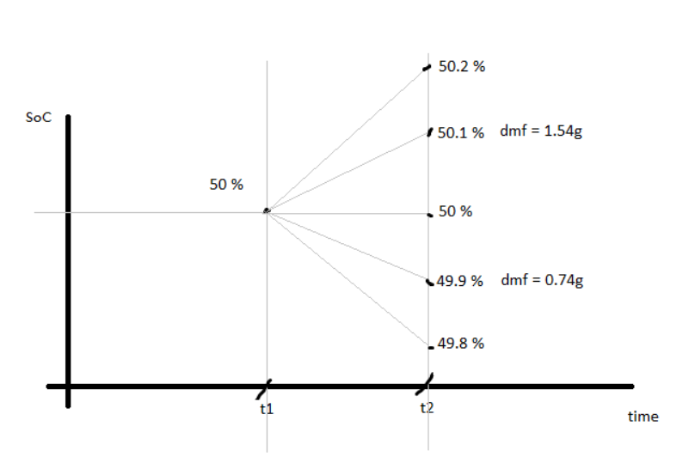
For whatever drive cycle we choose, for whatever time interval we choose, and whatever change in state of charge we choose, we can now calculate the corresponding fuel consumption. One can consider the fuel consumption of charging the battery from 50 to 50.1 % as the “cost” of that specific arc. During lectures and in the course literature you have probably heard the expression “arc-cost”, which is a term that refers to the corresponding fuel consumption of each “arc” above. The transitions between SoC(t1) and SoC(t2) above are called “arcs”.

For a drive cycle, the total fuel consumed is just a matter of adding up the arc-costs, as shown below.
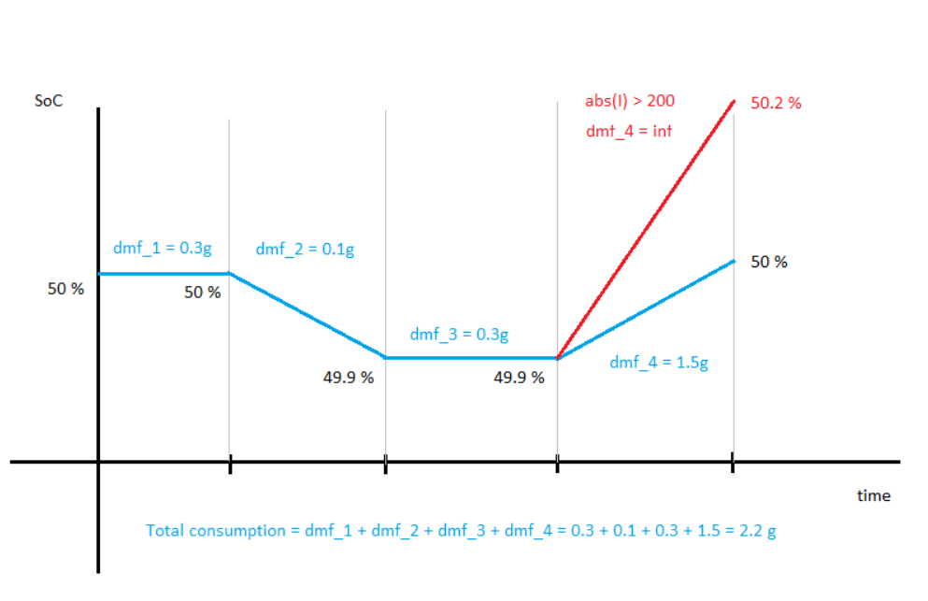

Note: The actual values in the figure above are made up and are only qualitatively correct.
In red, we show one of the disallowed actions since it exceeds the current limit of 200 ampere. The total fuel consumption for the blue path is the sum of the arc costs and ends up at 2.2 gram. If we would have followed the red arc, the total fuel consumption would be infinite.
It is important to understand that the only thing that really matters to us is the total fuel consumption. A viable strategy might be to charge the battery during the first half of the drive cycle, which would require a considerable amount of fuel, but would leave extra stored energy to be used in the remaining second half. Additionally, we have encoded information about disallowed actions in the fuel consumption. If we ask the powertrain model for an action that is not physically possible, it will provide us with infinite fuel consumption.
The drive cycle is a short segment designed to represent a certain type of driving. We will consider one drive cycle that represents highway driving, and one that represents city driving. The total distance covered for each drive cycle is quite short, however, but we can think of the drive cycles as representative sections of a much longer driving mission. Consider what would happen if we used an energy management strategy that leaves the vehicle with less than 50 % SoC at the end of a drive cycle, as in the figure below.
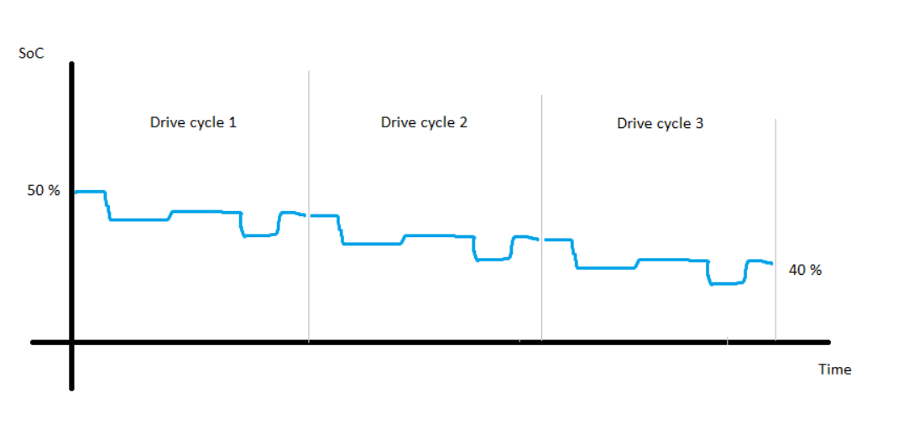
The battery discharges energy on average, and we can see that it won’t take long before the state of charge reaches zero.
This is precisely the result we will find unless we explicitly forbid it. In fact, if the only thing that matters is the total fuel consumption over one drive cycle, the optimization algorithm will shamelessly discharge the battery as much as possible during that cycle, because the algorithm doesn’t know we intend to continue driving after the cycle is finished. We need to impose an additional constraint in the optimization to prevent this issue. We will introduce a constraint to make sure that the final state of charge is no less than 50 %. This constraint is called the “final cost”.

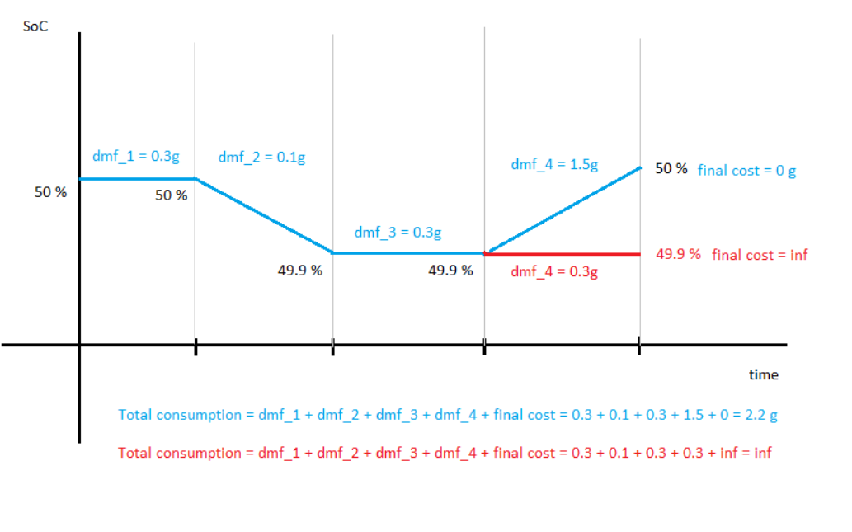
Note that the addition of this final cost does not occur when calculating the arc costs. It is an extra penalty that is added to the total consumption, during optimization. For the parallel hybrid, the final cost will be a vector disallowing a final state of charge below 50 %. For the series hybrid, the final cost will be a matrix, disallowing a final state of charge below 50 % for all possible engine speeds. There is no final cost associated with engine speed, the vehicle may end the drive cycle at any allowed speed. One can view the final cost as an “obstacle”, as shown in the figure below. Notice that the final engine speed does not contribute to the final cost matrix for the series case.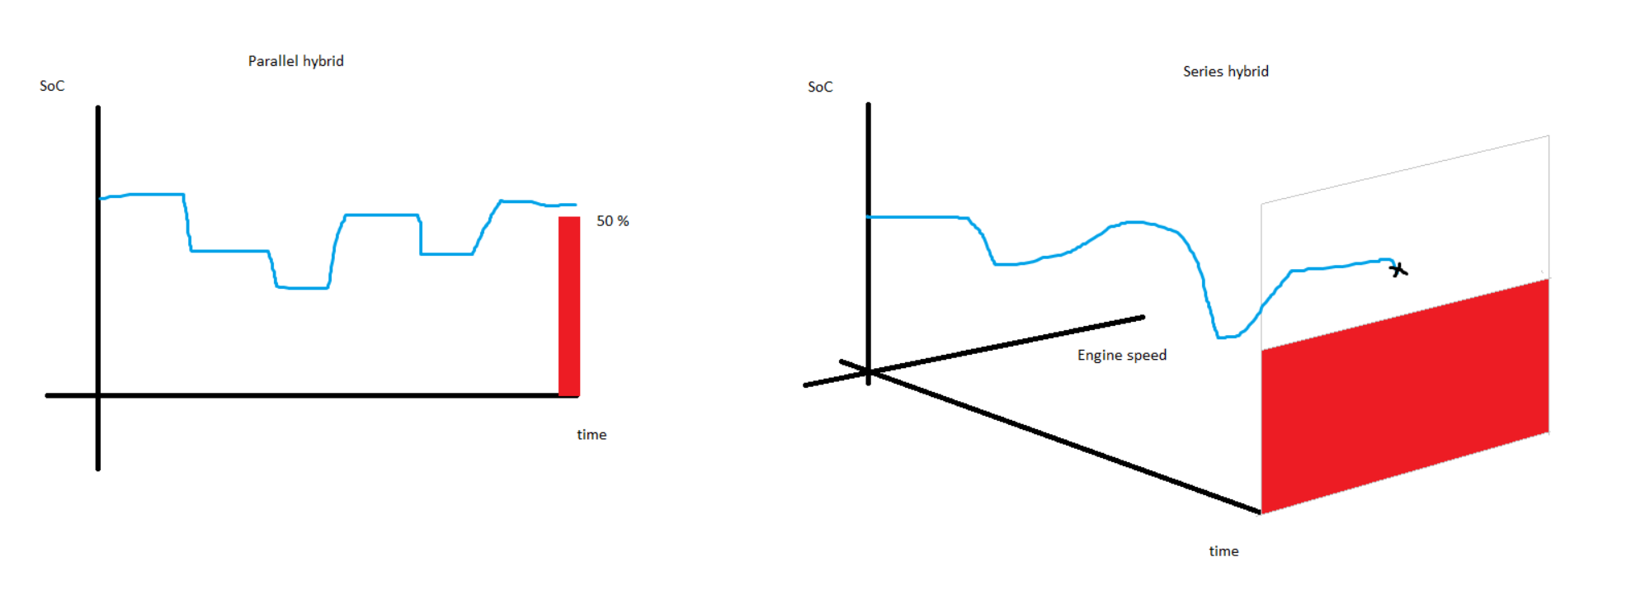

Consider the three control strategies shown in the figure below.
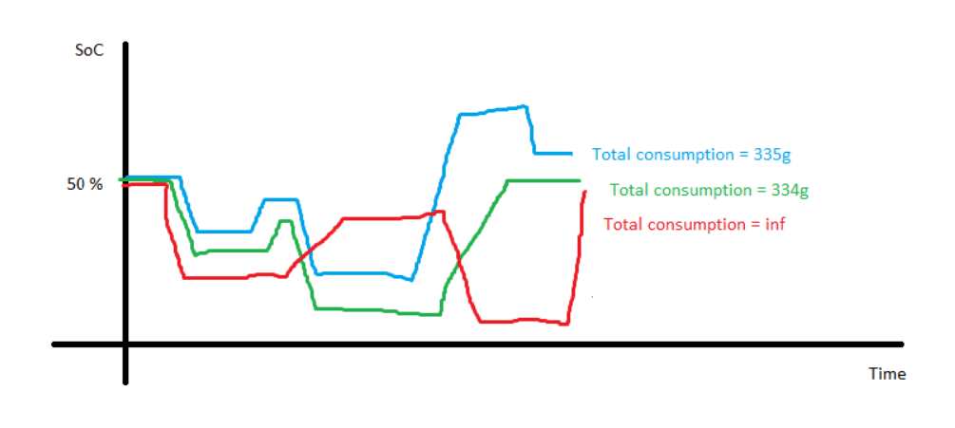
The blue and green are valid strategies. The total fuel consumptions are finite numbers, so no limits have been exceeded during the cycle, and the SoC ends above 50 %. The red strategy finishes at 50 %, but starts charging too late, so more than 200 ampere is required for that final push, resulting in an infinite consumption.
Out of these three, the best strategy is the green, as it finishes with the lowest fuel consumption.
Determining the superior strategy is easy if we have a given set of strategies to compare, as in the case above, with red, green, and blue. The reason is that we have encoded all the information we need in the fuel consumption itself. Strategies that break limits or fall below 50 % at the final interval will have infinite consumption, so all we must do to evaluate a set of strategies is to compare a single number.
The difficult part is finding the set of strategies to compare. We may calculate the total number of potential strategies for a time grid of size 195 and SoC-grid of size 1000. (195 time intervals in the drive cycle, and the SoC is allowed to take 1000 discrete points, for example 50.001 %, 50.002 % … and so on).
The number of possible control strategies in this case is
$${1000}^{195}=A very large number$$

We will instead rely on the dynamic programming algorithm, which we will demonstrate below.
To simplify the following exposition, we will allow only three levels of state of charge:
- Three: 50.1 %.
- Two: 50 %
- One: 49.9 %
Using only these three values will provide key insights in the workings of dynamic programming, while keeping the complexity at a reasonable level. (They are called one, two, and three, so that the names match the first, second, and third columns in a table or matrix)

Let’s start by looking at the final time interval, which we assume to be [194 195].
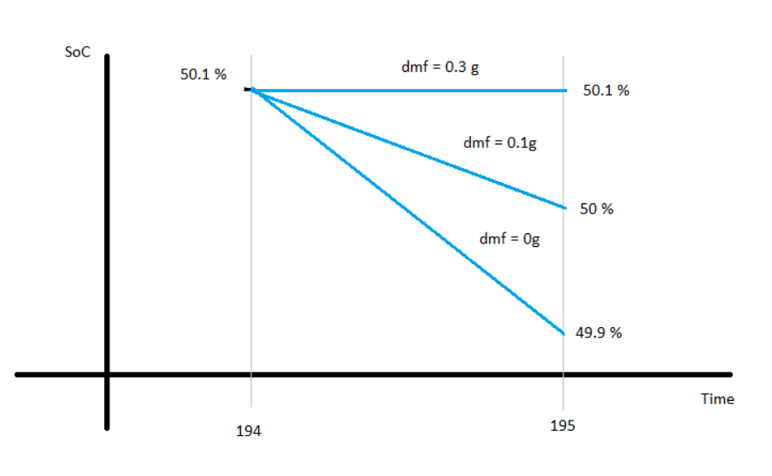
Starting from the third point, we can calculate the fuel consumption of going to any of the three SoC-levels during this interval. Remember that this calculation is precisely what you have been working on during the previous tutorials.
We calculate the total fuel consumption and determine the minimum.
Obviously, 0g is the minimum if we only consider the arc-costs, but remember that this is the final interval, so finishing below 50 % should result in infinite consumption. Therefore, 0.1g is the lowest fuel consumption possible when starting from 50.1 % SoC, the third point.
Now, let’s do the same for the other possible starting points, two and one.
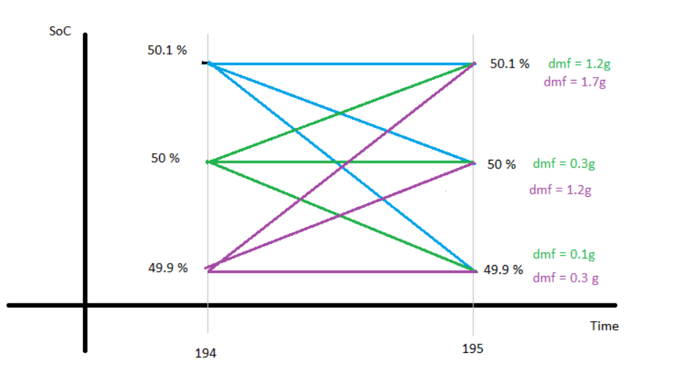
(Even with only three SoC-levels, the graphs become somewhat cluttered, but hopefully the point comes across.)
We can easily determine which strategies that, so far, result in the lowest fuel consumption. They are listed below for each starting point.
- 3 to 2: 0.1 g
- 2 to 2: 0.3 g
- 1 to 2: 1.2 g
Take a moment and make sure that you agree with our conclusions. Also note that, in spirit, we have performed the following function calls, which you are now familiar with:
- $parallelhybrid(\left[194 195\right], 0.501, \left[0.499, 0.500, 0.501\right])$
- $parallelhybrid(\left[194 195\right], 0.500, \left[0.499, 0.500, 0.501\right])$
- $parallelhybrid(\left[194 195\right], 0.499, \left[0.499, 0.500, 0.501\right])$

We will keep a record of the best strategies for each interval in a table. So far, we have
Interval \ SoC-Level | 1 | 2 | 3
[194,195] | 2 | 2 | 2

That is, for every starting point in interval [194, 195], the action that minimized the total fuel consumption was to go to SoC-level 2.
We may also keep a record the total fuel consumption.
Interval \ fuel cons. | 1 | 2 | 3
[194,195] | 1.2 | 0.3 | 0.1

Now, let’s move on to evaluate interval [193,194], and consider the starting point 3.
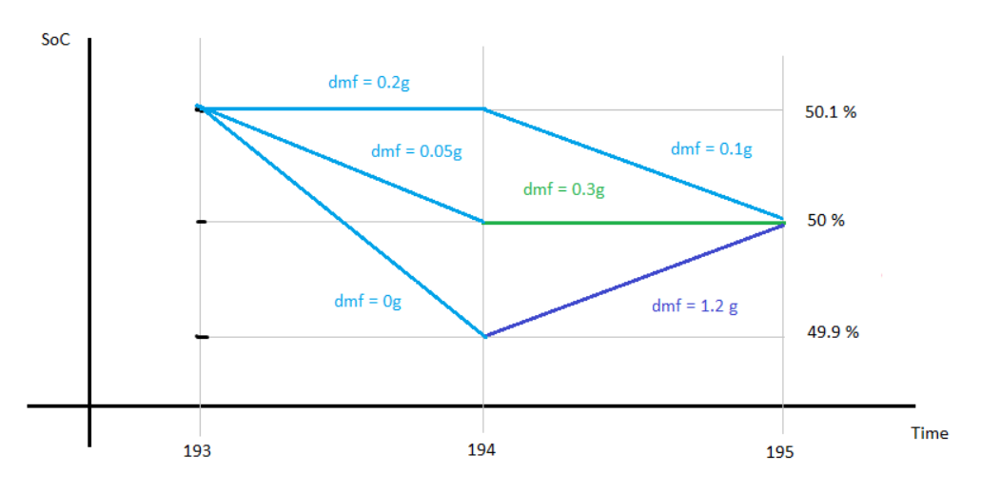
We keep the work we have done for the interval [194,195], and we determine, again, the best control strategy that result in the lowest total fuel consumption.
The strategy 3-2-2 has a total fuel consumption 0.3 + 0.05 = 0.35.
The strategy 3-3-2 has a total fuel consumption 0.2 + 0.1 = 0.3.
The strategy 3-1-2 has a total fuel consumption 0 + 1.2 = 1.2

We determine that the best strategy is 3-3-2, and we fill our table accordingly.
Interval \ SoC-Level | 1 | 2 | 3
[193,194] |  |  | 3
[194,195] | 2 | 2 | 2

And
Interval \ Fuel cons. | 1 | 2 | 3
[193,194] |  |  | 0.3
[194,195] | 1.2 | 0.3 | 0.1

We have not yet made the calculations for starting in point 1 or 2 for interval [193,194], so we leave those entries blank for now. They are calculated in the same way, but the figure would be too cluttered to read.
The fact that we’re allowed to “remember” the total consumption from earlier calculations is due to the principle of optimality, as discussed earlier.
The full statement is:
“Principle of Optimality: An optimal policy has the property that whatever the initial state and initial decision are, the remaining decisions must constitute an optimal policy with regard to the state resulting from the first decision.” (Bellman, 1957)
Take a moment to consider how the principle of optimality applies in our case.
If we continue calculating in this fashion until reaching the first interval, we end up with the following tables:
Interval \ SoC-Level | 1 | 2 | 3
[1,2] | 1 | 2 | 3
[2,3] | 1 | 3 | 3
$$⋮$$ | $$⋮$$ | $$⋮$$ | $$⋮$$
[192,193] | 2 | 2 | 3
[193,194] | 2 | 3 | 3
[194,195] | 2 | 2 | 2

Interval \ Fuel cons. | 1 | 2 | 3
[1,2] | 40.2 | 40.1 | 40
[2,3] | 40.1 | 40 | 39.9
$$⋮$$ | $$⋮$$ | $$⋮$$ | $$⋮$$
[192,193] |  |  | 3
[193,194] | 1.5 | 0.45 | 0.3
[194,195] | 1.2 | 0.3 | 0.1

(Note that these values are made up in order to demonstrate the idea, and need not be consistent with what you would actually get when calculating this example.)
Notice that the total fuel consumption is added up in reverse. What we see in row one is the total required fuel for completing the drive cycle. The “cost-to-go”.
The columns, again, refer to the possible state of charge levels, 49.9, 50, 50.1 %.
We can decide freely what state of charge we would like at the beginning of the drive cycle (in interval [1,2]). Dynamic programming gives us the optimal control strategy for all possible starting points.
If we select 50 % as our beginning state of charge, we can extract the optimal strategy as follows:
Interval \ SoC-Level | 1 | 2 | 3
[1,2] | 1 | 2 | 3
[2,3] | 1 | 3 | 3
$$⋮$$ | $$⋮$$ | $$⋮$$ | $$⋮$$
[192,193] | 2 | 2 | 3
[193,194] | 2 | 3 | 2
[194,195] | 2 | 2 | 2

That is, the table entries give the SoC-level for the following interval.
The total fuel consumption is easier to extract. Since it’s calculated in reverse, we get the total amount in the first row:
Interval \ Fuel cons. | 1 | 2 | 3
[1,2] | 40.2 | 40.1 | 40
[2,3] | 40.1 | 40 | 39.9
$$⋮$$ | $$⋮$$ | $$⋮$$ | $$⋮$$
[192,193] |  |  | 3
[193,194] | 1.5 | 0.45 | 0.3
[194,195] | 1.2 | 0.3 | 0.1

When calling “dynProg1D()”, the outputs matrices are the two tables we have discussed above.
When solving the series hybrid case, the idea is the same, but we will have an extra dimension. Instead of just SoC-levels, we also have engine speed levels, and the output matrices will be three dimensional.

Exercise 1. Open “runOptimization.m”. Load the City drive cycle. Set the time grid to “T_z”, the SoC-grid to [0.499, 0.5, 0.501], and initial SoC to 0.5. Choose an appropriate final cost vector.

Exercise 2. Predict the SoC behaviour. What would you expect the state of charge curve to look like? Would there be a correlation with vehicle speed?

Exercise 3. Run the optimization. Write a for-loop that finds the SoC-path, given that the initial SoC is 50 %. (See discussion above). Compare your results and prediction from Exercise 2.
Note: “Value” corresponds to the fuel consumption table above, and “SOC_path” to the SoC-table.

(The following exercises mirror the actual tasks required for hand-in 2)
For the parallel hybrid, there are four vehicle configurations we want you to compare:
- A conventional (only ICE) powertrain where the ICE has been scaled to the same maximum power output as the hybrid vehicle.
- A conventional powertrain where the ICE isn’t scaled.
- A hybrid powertrain that doesn’t use the battery, i.e., the electrical components are acting as dead weight.
- A hybrid powertrain that’s allowed to use the battery.

Exercise 4. Run the optimization for a conventional vehicle with the same maximum
power as the hybrid powertrain.
Note: Remove the mass of the electrical components, add the extra engine mass, and scale the engine parameters according to the discussion at the end of tutorial 2. To make sure that the vehicle doesn’t use the battery, you can let the SoC-grid be [0.5, 0.6]. The jump from 50 to 60 % will be too large, so essentially SoC will be locked at 50 %. (It would be reasonable to just use [0.5] as SoC-grid, but this has caused errors with matrix dimensions in the past, due to the implementation of dynprog1D().)

Exercise 5. Rerun the same optimization as in exercise 4, but do not scale the engine.
Note: Now remove the mass of the electrical components, but do not add the extra engine mass and do not scale the engine parameters. Restrict the battery to 50 %.

Exercise 6. Run the optimization for the hybrid powertrain but restrict the battery to 50 % SoC.
Note: Do not remove any mass. Restrict the battery to 50 %.

Exercise 7. Now run the DDP-algorithm for the full hybrid, allowing battery use
Note: One way to find an appropriate SoC-grid is to start with something small and increase it based on the results of the optimization. Say we begin with a grid size of 1000 points between 49 and 51 %. If we ever hit the endpoints, 49 or 51, we widen the grid slightly and rerun. If the SoC doesn’t hit the endpoints, we know we’ve chosen a large enough grid. (The same way we only shovel snow where we intend to walk).
But how many points should we use? Partitioning the SoC into discrete levels is an approximation, and we would like the error caused by this approximation to have a tiny effect on the calculated fuel consumption. Therefore, we should add points in the grid until the decrease in fuel consumption becomes negligible. Guess an initial number of points and then increase it to see how it affects the result.
A useful matlab-function to generate the grid is linspace().

